驻开普敦总领事任发强
会见南非鲍鱼出口理事会主席普勒赛斯
2026年10月14日，中国驻开普敦总领事任发强在馆内会见南非鲍鱼出口理事会主席普勒赛斯一行，就深化双边鲍鱼产业经贸合作进行友好交流，王晓副总领事参加。
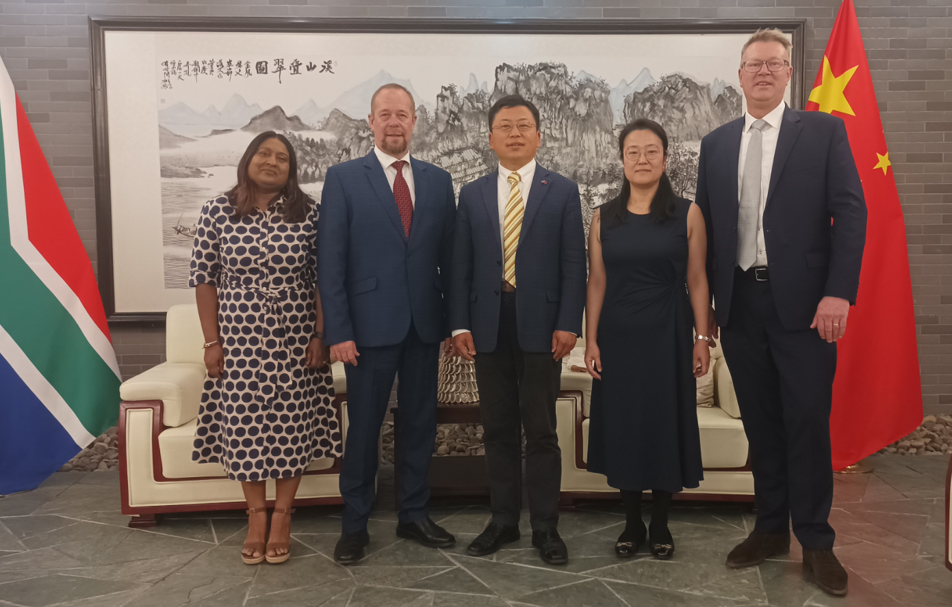
任总领事称赞南非鲍鱼独具特色品质，受到中国消费者欢迎，表示总领馆愿继续为两国经贸合作提供便利和支持。
普勒赛斯主席介绍南非鲍鱼生产和对华出口概况，表示中国是南非鲍鱼最大市场，赞赏中方对非洲建交国产品实施“零关税”政策，感谢总领馆的支持，期待深化对华合作。

Consul General Ren Faqiang Meets with
SAAEC’s Chairman Mr Jacques du Plessis

On October 14, 2026, Ren Faqiang, Consul General of the People’s Republic of China in Cape Town, met with Mr Jacques du Plessis, the Chairman of the Board of South African Abalone Export Council (SAAEC) at the Consulate General, having a friendly exchange on deepening bilateral economic and trade cooperation in the abalone industry. Deputy Consul General Wang Xiao attended the meeting.
Consul General Ren praised the unique quality of South African abalones, which are popular among Chinese consumers, and expressed that the Consulate General is willing to continue to provide convenience and support for economic and trade cooperation between the two countries.

Mr Plessis introduced South Africa abalone production and exports to China, stated that China is the largest market for South African abalones and appreciated China's implementation of a "zero-tariff" policy on products from countries with diplomatic relations with Africa. He also thanked Consul General Ren and Consulate general for their support on the development of the South African abalones industry, and looked forward to deepening the practical cooperation with China.

